**SALES SHEET**

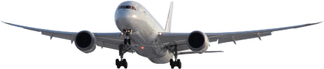

**BUSINESS TRAVEL MANAGEMENT**

**VISA AND IMMIGRATION**



P.O Box 71150, Nigeria

45 Oduduwa Way, GRA Ikeja, Lagos Nigeria.

Email: holidays@btmlimited.net

# BTM has an extensive range of products and services, which may be specifically tailored to suit each individual client’s requirements.

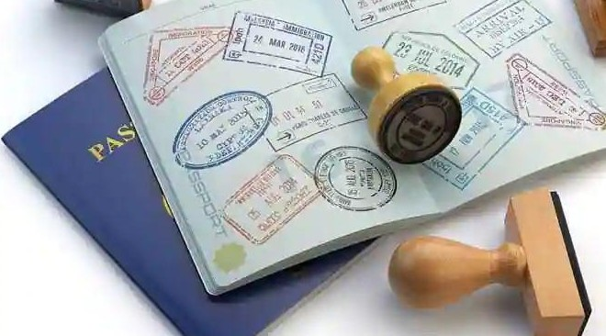

**VISA AND IMMIGRATION SERVICES**

Included in our bouquet of services is the BTM Nigeria Protocol

BTM Nigeria has a team who are trained to offer efficient visa and immigration services to our clients.

BTM Nigeria’s Visa and Immigration department is wholly owned and operated by BTM.

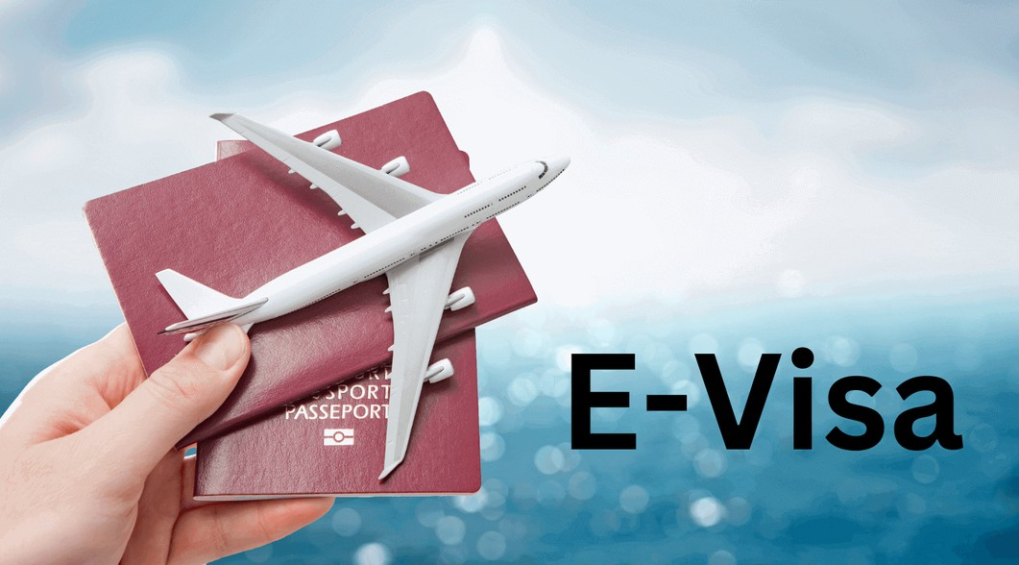

**VISA PROCESSING (ONLINE)**

Process Name: VISA PROCESSING (Application through VFC) Triggers: Business meetings, Trainings, Academic and Personal visits





**VISA PROCESSING (ONLINE)**

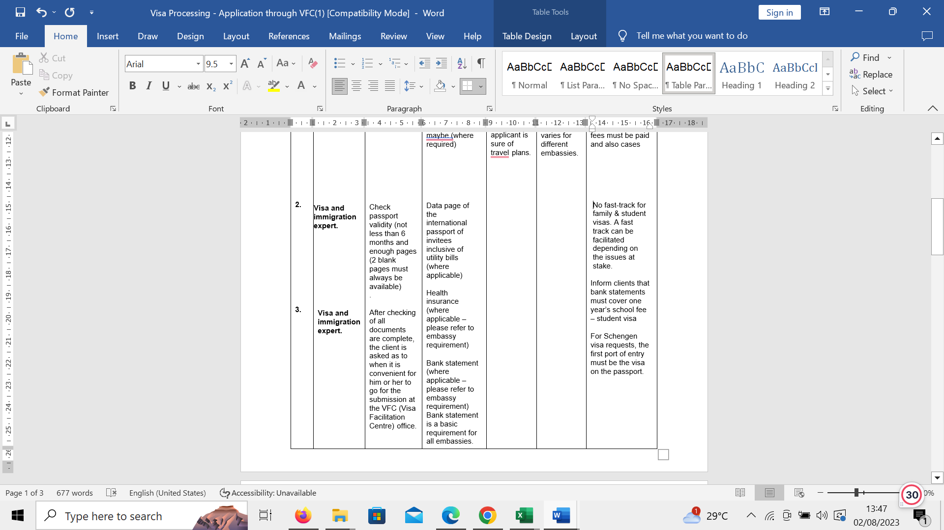

Process Name: VISA PROCESSING (Application through VFC) Triggers: Business meetings, Trainings, Academic and Personal visits

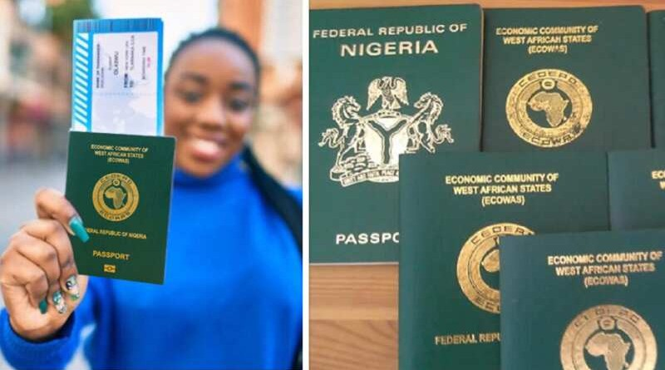

**VISA PROCESSING (ONLINE)**

Process Name: VISA PROCESSING (Application through VFC) Triggers: Business meetings, Training, Academic and Personal visits

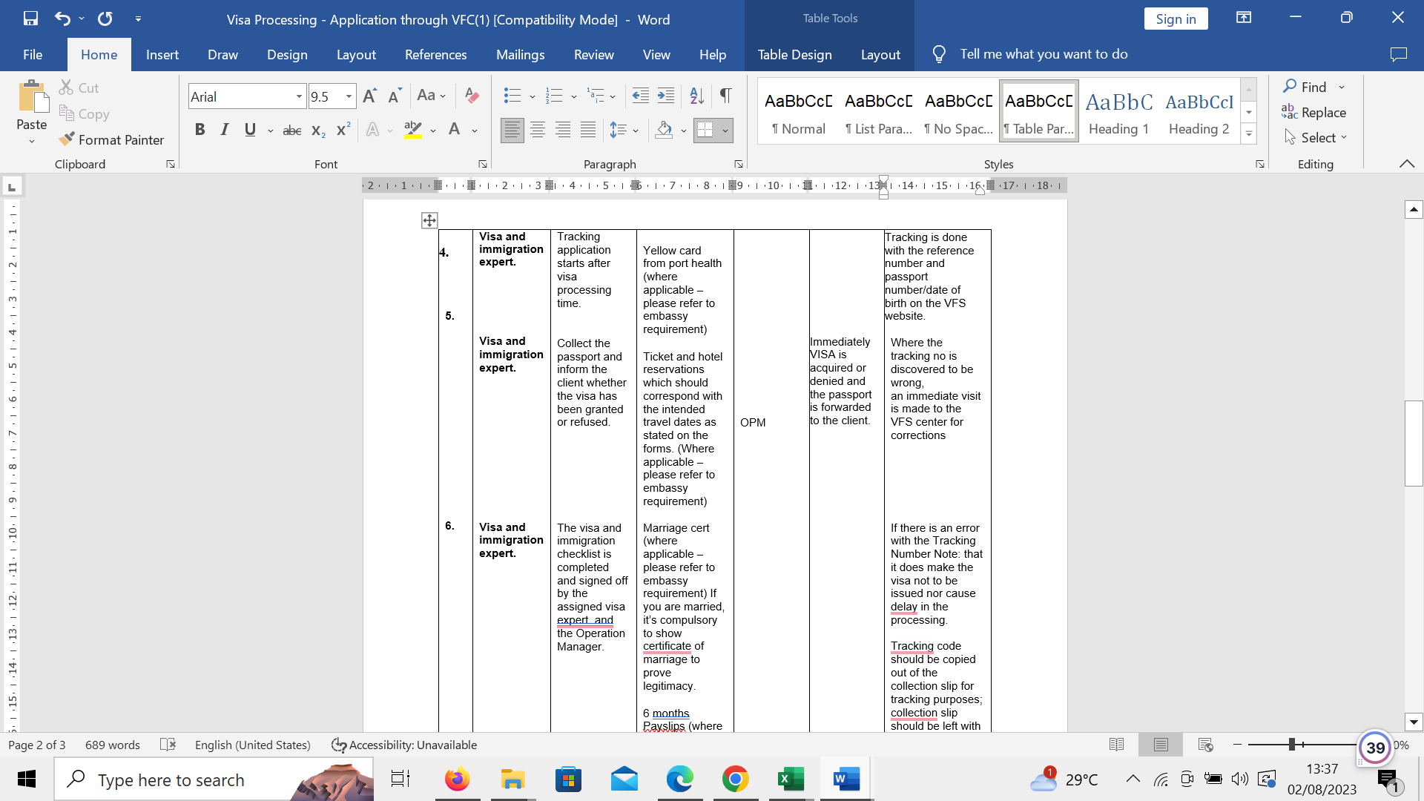





**Financial Note:**

**FINANCIAL NOTES**

1. Any international service or fare purchased in foreign currency must be paid for in the same currency or U$D in advance or via card/ deposit

2. Electronic document delivery only

3. Customized OBT Booking fees are available upon request for SME clients

4. Billing in Naira at the prevailing market rate as evident in Business Day Newspaper or an equivalent National Newspaper

5. Payment is at POS either via credit card or bank transfer

6. All applicable merchant fees for Credit/ Debit card payments are a pass-through cost

**BE MANAGED BY THE BEST.**



P.O Box 71150, Nigeria

45 Oduduwa Way, GRA Ikeja, Lagos Nigeria.